ANNAMACHARYA INSTITUTE OF TECHNOLOGY AND SCIENCES
TIRUPATI
(Approved by AICTE | Affiliated to JNTUA)
DEPARTMENT OF ARTIFICIAL INTELLIGENCE AND DATA SCIENCE

A MINI PROJECT REPORT ON
“OneSlot”
An Online Appointment Booking & Slot Management System

Submitted in partial fulfilment of the requirements for the award of the degree of
BACHELOR OF TECHNOLOGY
in ARTIFICIAL INTELLIGENCE AND DATA SCIENCE

Submitted by
N.YUDESHNA
G.SRAVANTH
K.HARISH
Roll No: 23AK1A30B9
23AK1A30A0
24AK5A3004

III B.Tech II Semester
Academic Year 2025 – 2026

Abstract

The recruitment process plays a crucial role in identifying and selecting suitable candidates for job opportunities. In traditional recruitment systems, recruiters are required to manually review numerous resumes and applications, which is time-consuming, labor-intensive, and prone to inconsistencies. As the number of job applicants increases, managing applications efficiently becomes a significant challenge for organizations.
The AI Job Application Tracking System is designed to automate and simplify the recruitment process by providing an intelligent platform for both recruiters and job seekers. The system enables recruiters to create job postings, manage applications, evaluate candidates, and track recruitment progress. Candidates can register, create profiles, upload resumes, search for available jobs, and apply for positions through a user-friendly interface.
A key feature of the system is the integration of an Artificial Intelligence-based resume scoring module. The AI engine analyzes uploaded resumes, extracts relevant information, compares candidate skills with job requirements, and generates an ATS (Applicant Tracking System) score. This score helps recruiters identify the most suitable candidates quickly and efficiently, reducing the effort required for manual resume screening.
The system is developed using React.js for the frontend, Node.js and Express.js for the backend, MongoDB for database management, and Python for implementing the AI-based resume evaluation module. By combining modern web technologies with artificial intelligence, the proposed system improves recruitment efficiency, enhances candidate evaluation, and provides a streamlined hiring experience for both recruiters and applicants.
Keywords: Artificial Intelligence, Applicant Tracking System (ATS), Recruitment Management, Resume Analysis, Candidate Ranking, React.js, Node.js, MongoDB.

ACKNOWLEDGEMENT

We take this opportunity to express our sincere gratitude to all those who have directly or indirectly contributed to the successful completion of our mini project titled “AI Job Application Tracking System.”
We are grateful to Annamacharya Institute of Technology and Sciences, Tirupati, for providing us with the necessary facilities, resources, and academic environment to carry out this project successfully.

We extend our heartfelt thanks to the Department of Artificial Intelligence & Data Science for their continuous encouragement and support throughout the development of this project.
We would also like to express our appreciation to all the faculty members of our department for their valuable suggestions, guidance, and motivation, which helped us complete this project effectively.
We are thankful to our friends and classmates for their cooperation, constructive feedback, and support during various stages of project development.

Finally, we express our deepest gratitude to our parents and family members for their constant encouragement, moral support, and inspiration throughout our academic journey.
We sincerely acknowledge everyone who contributed to the successful completion of this project.

Project Team
N. Yudeshna
G. Sravanth
K. Harish

Table of Contents

Chapter No. | Title | Page No.
Certificate | Certificate | i
Acknowledgement | Acknowledgement | ii
Abstract | Abstract | iii
Table of Contents | Table of Contents | iv
Chapter 1 | Introduction | 1
1.1 | Overview of the Project | 2
1.2 | Need for the System | 3
1.3 | Scope of the Project | 4
Chapter 2 | Problem Statement | 5
2.1 | Existing Problems in Recruitment | 5
2.2 | Challenges in Manual Screening | 6
Chapter 3 | Objectives | 7
3.1 | Main Objectives | 7
Chapter 4 | Existing System | 8
4.1 | Limitations of Existing Systems | 8
Chapter 5 | Proposed System | 9
5.1 | Features of Proposed System | 10
5.2 | Advantages of Proposed System | 10
Chapter 6 | System Architecture | 11
6.1 | Architecture Diagram | 11
6.2 | Working of the System | 12
Chapter 7 | Technology Stack | 13
7.1 | Frontend Technologies | 13
7.2 | Backend Technologies | 14
7.3 | Database Technologies | 14
7.4 | AI Module Technologies | 15
Chapter 8 | Module Description | 16
8.1 | Authentication Module | 16
8.2 | Candidate Module | 17
8.3 | Recruiter Module | 18
8.4 | Resume Upload Module | 19
8.5 | ATS Scoring Module | 20
Chapter 9 | Database Design | 21
9.1 | User Collection | 21
9.2 | Job Collection | 22
9.3 | Application Collection | 22
Chapter 10 | Implementation | 23
10.1 | Frontend Implementation | 23
10.2 | Backend Implementation | 24
10.3 | AI Module Implementation | 25
Chapter 11 | Results and Screenshots | 26
11.1 | Login Page | 26
11.2 | Candidate Dashboard | 27
11.3 | Recruiter Dashboard | 28
11.4 | Job Search Page | 29
11.5 | ATS Score Display | 30
Chapter 12 | Future Scope | 31
Chapter 13 | Conclusion | 32
References | References | 33
Appendix | Source Code Snapshots | 34

CHAPTER 1: INTRODUCTION
1.1 Overview of the Project
Recruitment is an essential process for every organization, as it helps identify and select suitable candidates for various job positions. With the increasing number of job applicants, manual recruitment processes have become inefficient and time-consuming. Recruiters often spend considerable effort reviewing resumes, shortlisting candidates, and managing applications.
The AI Job Application Tracking System is a web-based recruitment management platform designed to simplify and automate the hiring process. The system provides separate interfaces for recruiters and candidates, enabling efficient communication and application management.
Candidates can create profiles, upload resumes, search available job opportunities, and apply for suitable positions. Recruiters can post jobs, manage applications, evaluate candidates, and monitor recruitment activities through a centralized dashboard.
A significant feature of the project is the integration of Artificial Intelligence for resume evaluation. The AI module analyzes candidate resumes and generates an ATS (Applicant Tracking System) score based on the relevance of candidate skills and qualifications to job requirements. This allows recruiters to identify suitable candidates more effectively.

1.2 Need for the System
The recruitment industry is rapidly evolving due to technological advancements and increasing competition among job seekers. Traditional recruitment methods are often inefficient because recruiters must manually review a large number of applications.
The need for an AI-based recruitment system arises from the following challenges:
- Large volume of applications for a single job opening.
- Time-consuming manual resume screening.
- Difficulty in evaluating candidates consistently.
- Lack of automated candidate ranking.
- Limited application tracking mechanisms.
- Increased workload for recruiters.
The AI Job Application Tracking System addresses these challenges by automating candidate evaluation and application management processes.

1.3 Scope of the Project
The scope of the AI Job Application Tracking System includes the development of a complete recruitment platform that supports both recruiters and candidates.
The system provides:
For Candidates
- User Registration and Login
- Profile Management
- Resume Upload
- Job Search
- Job Applications
- Application Status Tracking
For Recruiters
- Recruiter Registration and Login
- Job Posting
- Applicant Management
- Candidate Evaluation
- ATS Score Review
- Application Status Updates
AI-Based Features
- Resume Analysis
- Skill Matching
- ATS Score Generation
- Candidate Ranking
The project can be further extended by integrating interview scheduling, email notifications, advanced analytics, and cloud deployment.

1.4 Benefits of the Project
The proposed system offers several benefits:
- Reduces manual recruitment effort.
- Improves recruitment efficiency.
- Enables objective candidate evaluation.
- Provides automated ATS scoring.
- Enhances candidate experience.
- Simplifies application tracking.
- Supports scalable recruitment processes.
By leveraging artificial intelligence and modern web technologies, the system provides a practical solution for recruitment management in organizations of different sizes.

CHAPTER 2: PROBLEM STATEMENT AND EXISTING SYSTEM
2.1 Problem Statement
Recruitment is a critical process in every organization. Companies receive a large number of job applications for various positions, making candidate screening and selection a challenging task. In traditional recruitment systems, recruiters manually review resumes, compare candidate qualifications, and shortlist suitable applicants. This process requires significant time and effort, especially when dealing with hundreds of applications.
Manual screening often leads to inconsistencies in candidate evaluation and may result in qualified candidates being overlooked. Additionally, managing applications through emails, spreadsheets, or paper-based methods makes tracking candidate progress difficult.
There is a need for an intelligent recruitment platform that can automate application management, evaluate resumes efficiently, and assist recruiters in identifying the most suitable candidates. The AI Job Application Tracking System addresses these challenges by providing an automated and centralized recruitment solution.

2.2 Existing System
In the existing recruitment process, organizations commonly use manual methods or basic online job portals for hiring. Recruiters post job openings and receive applications through emails or external platforms. Each application is reviewed individually, and candidate information is managed manually.
The existing process generally includes:
- Posting job vacancies.
- Receiving resumes through emails or job portals.
- Manually reviewing candidate profiles.
- Shortlisting candidates based on recruiter judgment.
- Communicating with candidates individually.
- Tracking recruitment progress manually.
Although online job portals simplify job posting, they often lack intelligent candidate evaluation and automated ranking mechanisms.

2.3 Limitations of Existing System
The existing recruitment process suffers from several limitations:
1. Time-Consuming Resume Screening
Recruiters must manually examine each resume, which becomes difficult when the number of applications is high.
2. Lack of Candidate Ranking
There is no automatic mechanism to rank candidates based on their suitability for a specific job role.
3. Human Bias and Inconsistency
Different recruiters may evaluate candidates differently, leading to inconsistent hiring decisions.
4. Poor Application Tracking
Managing applications through emails and spreadsheets makes tracking candidate status difficult.
5. Increased Recruiter Workload
Manual handling of applications increases the workload and reduces recruitment efficiency.
6. Limited Feedback for Candidates
Candidates often do not receive clear information about their application progress.

2.4 Need for the Proposed System
To overcome the limitations of traditional recruitment systems, an automated and intelligent solution is required. The AI Job Application Tracking System provides:
- Automated application management.
- Secure role-based access.
- Resume upload and storage.
- AI-powered ATS score generation.
- Candidate ranking based on suitability.
- Efficient tracking of application status.
- Improved recruiter productivity.
The proposed system significantly reduces manual effort while improving the accuracy and efficiency of the recruitment process.

CHAPTER 3: PROPOSED SYSTEM
3.1 Introduction
The proposed system, AI Job Application Tracking System, is designed to automate and simplify the recruitment process by providing a centralized platform for recruiters and job seekers. The system integrates Artificial Intelligence techniques with modern web technologies to improve candidate evaluation and recruitment efficiency.
The platform enables recruiters to create and manage job postings, review applications, and evaluate candidates based on ATS scores. Candidates can create profiles, upload resumes, search available jobs, and apply for suitable positions through a user-friendly interface.
Unlike traditional recruitment systems, the proposed system incorporates an AI-powered resume scoring mechanism that helps recruiters identify qualified candidates quickly and accurately.

3.2 Proposed System Overview
The AI Job Application Tracking System consists of three major components:
1. Frontend Application
The frontend provides a user-friendly interface for recruiters and candidates. It is developed using React.js and Tailwind CSS.
2. Backend Server
The backend handles authentication, job management, application processing, resume uploads, and communication between the database and AI module. It is developed using Node.js and Express.js.
3. AI Resume Scoring Module
The AI module analyzes uploaded resumes and generates ATS scores based on skill matching and resume relevance. It is developed using Python.

3.3 Features of Proposed System
Candidate Features
- User Registration and Login
- Profile Creation and Management
- Resume Upload
- Job Search and Filtering
- Job Application Submission
- Application Status Tracking
- Notifications
Recruiter Features
- Recruiter Registration and Login
- Job Posting Management
- Applicant Review
- Candidate Evaluation
- ATS Score Review
- Application Status Updates
AI Features
- Resume Analysis
- Skill Extraction
- Resume-Job Matching
- ATS Score Calculation
- Candidate Ranking

3.4 Advantages of Proposed System
The proposed system provides several advantages over traditional recruitment methods.
Automation
The system automates candidate evaluation and application management, reducing manual effort.
Faster Recruitment Process
Recruiters can quickly identify qualified candidates using ATS scores.
Improved Accuracy
AI-based evaluation reduces human bias and improves candidate selection accuracy.
Better Candidate Experience
Candidates can easily track their application progress through the platform.
Centralized Data Management
All recruitment activities are managed within a single platform.
Scalability
The system can handle a large number of applications efficiently.

3.5 Workflow of the Proposed System
The workflow of the AI Job Application Tracking System is as follows:
Step 1
Candidate registers and creates a profile.
Step 2
Candidate uploads a resume and searches available job opportunities.
Step 3
Candidate applies for a suitable job.
Step 4
The system stores the application details in the database.
Step 5
The AI module analyzes the uploaded resume and generates an ATS score.
Step 6
The ATS score is associated with the application.
Step 7
Recruiters review applicants and view ATS scores.
Step 8
Recruiters shortlist, reject, or hire candidates.
Step 9
Candidates receive updates regarding their application status.

3.6 Outcome of the Proposed System
The AI Job Application Tracking System provides an intelligent recruitment platform that simplifies application management and improves candidate evaluation. By combining Artificial Intelligence with full-stack web technologies, the system helps organizations reduce recruitment time, improve hiring quality, and enhance overall recruitment efficiency.
CHAPTER 4: SYSTEM ARCHITECTURE
4.1 Introduction
System architecture defines the overall structure and organization of the AI Job Application Tracking System. It describes how different components interact with each other to provide recruitment management and AI-based resume evaluation services.
The proposed system follows a multi-tier architecture consisting of a frontend layer, backend layer, database layer, and AI processing layer. Each layer performs specific tasks to ensure efficient operation and maintainability of the system.

4.2 Architecture Diagram
System Architecture
┌─────────────────────┐
│ Candidates │
│ Recruiters │
└──────────┬──────────┘
│
▼
┌─────────────────────────────┐
│ React Frontend │
│ Candidate & Recruiter UI │
└──────────────┬──────────────┘
│
▼
┌─────────────────────────────┐
│ Node.js + Express API │
│ Authentication & Business │
│ Logic Layer │
└───────┬───────────┬─────────┘
│ │
▼ ▼
┌────────────────┐ ┌────────────────┐
│ MongoDB │ │ Python AI │
│ Database │ │ Resume Scorer │
└────────────────┘ └────────────────┘

4.3 Components of the System
1. Frontend Layer
The frontend layer is responsible for providing an interactive user interface for candidates and recruiters.
Functions:
- User Registration
- User Login
- Job Search
- Job Application
- Profile Management
- Dashboard Access
- Application Tracking
Technologies Used:
- React.js
- Tailwind CSS
- React Router DOM
- Axios

2. Backend Layer
The backend layer acts as the core processing unit of the system. It handles authentication, business logic, API requests, and communication between the frontend and database.
Functions:
- Authentication
- Authorization
- Job Management
- Application Processing
- Resume Upload Management
- Notification Management
- API Services
Technologies Used:
- Node.js
- Express.js
- JWT Authentication
- Multer

3. Database Layer
The database layer stores all application data and maintains records required by the system.
Stored Information:
- User Details
- Recruiter Details
- Job Information
- Application Records
- ATS Scores
- Notifications
Technology Used:
- MongoDB
- Mongoose ODM

4. AI Processing Layer
The AI layer is responsible for analyzing uploaded resumes and generating ATS scores.
Functions:
- Resume Parsing
- Skill Extraction
- Resume Analysis
- ATS Score Calculation
- Candidate Ranking Support
Technology Used:
- Python
- Flask

4.4 Working of the System
The working of the AI Job Application Tracking System can be explained in the following steps:
Step 1: User Authentication
Candidates and recruiters register and log in to the system using secure credentials.
Step 2: Job Posting
Recruiters create and publish job opportunities through the recruiter dashboard.
Step 3: Job Search
Candidates browse available jobs and identify suitable opportunities.
Step 4: Resume Upload
Candidates upload their resumes while applying for jobs.
Step 5: Resume Analysis
The AI module processes the uploaded resume and extracts relevant information.
Step 6: ATS Score Generation
The AI engine compares resume content with job requirements and generates an ATS score.
Step 7: Application Management
The generated ATS score is stored along with application details.
Step 8: Candidate Evaluation
Recruiters review applications and evaluate candidates based on ATS scores and profile information.
Step 9: Status Update
Recruiters update application status such as:
- Applied
- Reviewing
- Shortlisted
- Rejected
- Hired
Step 10: Candidate Notification
Candidates can monitor application progress through their dashboard.

4.5 Benefits of the Architecture
The architecture provides several advantages:
- Modular Design
- Scalability
- Easy Maintenance
- Secure Authentication
- Efficient Data Management
- AI Integration Support
- Improved Recruitment Efficiency
The separation of frontend, backend, database, and AI modules ensures better performance and simplifies future enhancements.

CHAPTER 5: TECHNOLOGY STACK
5.1 Introduction
The AI Job Application Tracking System is developed using modern web technologies and Artificial Intelligence tools. The technology stack has been carefully selected to provide scalability, security, efficiency, and ease of development.
The project consists of four major layers:
- Frontend Layer
- Backend Layer
- Database Layer
- Artificial Intelligence Layer
Each layer uses specific technologies to perform its respective functions.

5.2 Frontend Technologies
React.js
React.js is an open-source JavaScript library used for building user interfaces and single-page applications.
Features of React.js:
- Component-Based Architecture
- Virtual DOM for faster rendering
- Reusable Components
- Better User Experience
- Efficient State Management
Role in the Project:
- Candidate Dashboard
- Recruiter Dashboard
- Login and Registration Pages
- Job Search Interface
- Profile Management
- Application Tracking

Tailwind CSS
Tailwind CSS is a utility-first CSS framework used for designing responsive and modern user interfaces.
Features:
- Rapid UI Development
- Responsive Design
- Reusable Utility Classes
- Improved Styling Flexibility
Role in the Project:
- Dashboard Design
- Forms and Buttons
- Navigation Bars
- Responsive Layouts

Axios
Axios is a JavaScript library used for making HTTP requests between the frontend and backend.
Role in the Project:
- User Authentication Requests
- Job Retrieval
- Application Submission
- Profile Updates
- Notification Fetching

5.3 Backend Technologies
Node.js
Node.js is a JavaScript runtime environment used for server-side development.
Features:
- Non-Blocking Architecture
- Event-Driven Programming
- High Performance
- Scalability
Role in the Project:
- API Development
- Request Handling
- Authentication Processing
- Business Logic Implementation

Express.js
Express.js is a lightweight web framework built on top of Node.js.
Features:
- Fast API Development
- Middleware Support
- Route Management
- RESTful Services
Role in the Project:
- Authentication APIs
- Job APIs
- Application APIs
- User APIs
- Notification APIs

JWT (JSON Web Token)
JWT is used to provide secure authentication and authorization.
Features:
- Secure User Authentication
- Stateless Sessions
- Role-Based Access Control
Role in the Project:
- User Login
- Session Management
- Protected Routes
- Access Control

Multer
Multer is a middleware used for handling file uploads.
Role in the Project:
- Resume Upload
- File Storage Management
- Resume Processing

5.4 Database Technology
MongoDB
MongoDB is a NoSQL document-oriented database used to store project data.
Features:
- Flexible Schema
- High Performance
- Scalability
- JSON-Like Documents
Role in the Project:
- User Data Storage
- Job Information Storage
- Application Records
- Notification Storage
- ATS Score Storage

Mongoose
Mongoose is an Object Data Modeling (ODM) library for MongoDB.
Features:
- Schema Validation
- Data Modeling
- Query Support
Role in the Project:
- User Model
- Job Model
- Application Model
- Notification Model

5.5 Artificial Intelligence Technology
Python
Python is used for implementing the AI-based resume scoring module.
Features:
- Easy Integration
- Rich AI Libraries
- High Readability
Role in the Project:
- Resume Analysis
- ATS Score Calculation
- Skill Matching

Flask
Flask is a lightweight Python web framework.
Features:
- Simple API Development
- Lightweight Architecture
- Easy Integration
Role in the Project:
- AI Service Development
- Resume Processing API
- ATS Score Generation API

5.6 API Testing Tool
Postman
Postman is used for testing APIs during development.
Functions:
- API Request Testing
- Authentication Testing
- Endpoint Validation
- Debugging
Role in the Project:
- Testing Login APIs
- Testing Job APIs
- Testing Application APIs
- Testing AI APIs

5.7 Summary
The combination of React.js, Node.js, Express.js, MongoDB, Python, and Flask provides a powerful full-stack architecture for developing the AI Job Application Tracking System. These technologies work together to ensure efficient recruitment management, secure authentication, intelligent resume evaluation, and seamless user interaction.

CHAPTER 6: MODULE DESCRIPTION
6.1 Introduction
The AI Job Application Tracking System is divided into multiple functional modules to ensure efficient management of recruitment activities. Each module performs specific tasks and contributes to the overall functionality of the system.
The major modules of the system are:
- Authentication Module
- Candidate Module
- Recruiter Module
- Job Management Module
- Application Management Module
- Resume Upload Module
- AI ATS Scoring Module
- Notification Module

6.2 Authentication Module
The Authentication Module provides secure access to the system by verifying user credentials and managing user sessions.
Features
- User Registration
- User Login
- Password Protection
- JWT Authentication
- Role-Based Access Control
Functions
Candidate Registration
Allows candidates to create an account using personal information.
Recruiter Registration
Allows recruiters to create accounts for recruitment activities.
Login Authentication
Validates user credentials and generates secure JWT tokens.
Authorization
Restricts access based on user roles.
Benefits
- Enhanced Security
- Secure Session Management
- Protection of Sensitive Data

6.3 Candidate Module
The Candidate Module provides functionalities required by job seekers.
Features
- Profile Creation
- Resume Upload
- Job Search
- Job Applications
- Application Tracking
- Notifications
Functions
Profile Management
Candidates can update personal information, skills, education, and contact details.
Job Search
Candidates can browse available job opportunities.
Job Application
Candidates can apply for suitable jobs directly through the platform.
Application Tracking
Candidates can monitor the status of submitted applications.
Benefits
- Easy Job Search
- Simplified Application Process
- Better Application Visibility

6.4 Recruiter Module
The Recruiter Module enables recruiters to manage recruitment activities efficiently.
Features
- Job Posting
- Applicant Management
- Candidate Evaluation
- Application Status Updates
- ATS Score Review
Functions
Job Creation
Recruiters can create and publish job opportunities.
Candidate Review
Recruiters can view applicant profiles and resumes.
Application Management
Recruiters can manage candidate applications.
Status Updates
Recruiters can update candidate status such as:
- Applied
- Reviewing
- Shortlisted
- Rejected
- Hired
Benefits
- Improved Recruitment Efficiency
- Centralized Candidate Management
- Faster Hiring Decisions

6.5 Job Management Module
The Job Management Module handles all job-related operations within the system.
Features
- Create Job Posts
- Update Job Information
- Delete Job Posts
- View Job Listings
Functions
Job Creation
Recruiters create jobs by specifying:
- Job Title
- Job Description
- Required Skills
- Experience Requirements
Job Listing
All active jobs are displayed to candidates.
Job Updates
Recruiters can modify job information whenever required.
Benefits
- Easy Job Administration
- Better Job Visibility
- Flexible Job Management

6.6 Application Management Module
The Application Management Module handles candidate applications and recruitment workflow.
Features
- Application Submission
- ATS Score Association
- Application Tracking
- Status Management
Functions
Application Submission
Candidates submit applications for selected jobs.
Application Storage
Application details are securely stored in MongoDB.
Application Review
Recruiters review applications and evaluate candidates.
Status Monitoring
Application progress is updated and tracked.
Benefits
- Organized Recruitment Workflow
- Efficient Candidate Tracking
- Reduced Manual Effort

6.7 Resume Upload Module
The Resume Upload Module allows candidates to upload resumes for evaluation.
Features
- PDF Resume Upload
- Secure Storage
- Resume Retrieval
Functions
File Upload
Candidates upload resumes during profile creation or job application.
Resume Storage
Uploaded resumes are stored securely and linked to candidate profiles.
Resume Access
Recruiters can view candidate resumes during evaluation.
Benefits
- Centralized Resume Management
- Easy Resume Access
- Improved Candidate Evaluation

6.8 AI ATS Scoring Module
The AI ATS Scoring Module is the core intelligent component of the system.
Features
- Resume Analysis
- Skill Extraction
- ATS Score Generation
- Candidate Ranking
Functions
Resume Processing
The uploaded resume is processed by the Python-based AI module.
Skill Extraction
Relevant skills and keywords are extracted from the resume.
ATS Score Calculation
The system generates an ATS score based on resume quality and job relevance.
Candidate Ranking
Recruiters can use ATS scores to identify suitable candidates.
Benefits
- Automated Resume Evaluation
- Faster Screening Process
- Improved Candidate Selection

6.9 Notification Module
The Notification Module provides important updates to users.
Features
- Application Updates
- Status Notifications
- Recruitment Alerts
Functions
Candidate Notifications
Candidates receive updates regarding application status changes.
Recruiter Notifications
Recruiters receive updates related to applications and recruitment activities.
Benefits
- Improved Communication
- Real-Time Updates
- Better User Experience

6.10 Summary
The modular architecture of the AI Job Application Tracking System ensures efficient operation, scalability, and maintainability. Each module performs a specific function while working together to provide a complete recruitment management solution. The integration of AI-powered ATS scoring further enhances the effectiveness of candidate evaluation and recruitment decision-making.

CHAPTER 7: DATABASE DESIGN
7.1 Introduction
Database design is an essential part of the AI Job Application Tracking System. The database is responsible for storing user information, job details, applications, ATS scores, and notifications. MongoDB is used as the database management system because of its flexibility, scalability, and efficient handling of large amounts of data.
The system uses multiple collections to organize and manage data efficiently.
The major collections used are:
- User Collection
- Job Collection
- Application Collection
- Notification Collection

7.2 User Collection
The User Collection stores information related to candidates and recruiters.
Attributes
Field Name | Data Type | Description
_id | ObjectId | Unique User ID
name | String | User Name
email | String | Email Address
password | String | Encrypted Password
role | String | Candidate/Recruiter/Admin
phone | String | Contact Number
skills | Array | Technical Skills
education | String | Educational Details
linkedin | String | LinkedIn Profile
github | String | GitHub Profile
about | String | User Description
resume | String | Resume Path
isActive | Boolean | Account Status
Purpose
The collection is used to manage authentication, user profiles, and candidate information.

7.3 Job Collection
The Job Collection stores job opportunities created by recruiters.
Attributes
Field Name | Data Type | Description
_id | ObjectId | Job ID
title | String | Job Title
description | String | Job Description
company | String | Company Name
location | String | Job Location
salary | Number | Salary Package
skills | Array | Required Skills
recruiter | ObjectId | Recruiter Reference
createdAt | Date | Creation Date
Purpose
This collection stores all active job postings available for candidates.

7.4 Application Collection
The Application Collection stores candidate applications submitted for jobs.
Attributes
Field Name | Data Type | Description
_id | ObjectId | Application ID
job | ObjectId | Job Reference
candidate | ObjectId | Candidate Reference
resume | String | Resume File
coverLetter | String | Cover Letter
status | String | Application Status
atsScore | Number | ATS Score
skills | Array | Extracted Skills
interviewDate | Date | Interview Schedule
Application Status Values
- Applied
- Reviewing
- Shortlisted
- Rejected
- Hired
Purpose
The collection maintains all job applications and recruitment workflow information.

7.5 Notification Collection
The Notification Collection stores notifications generated by the system.
Attributes
Field Name | Data Type | Description
_id | ObjectId | Notification ID
user | ObjectId | User Reference
message | String | Notification Message
isRead | Boolean | Read Status
createdAt | Date | Notification Date
Purpose
The collection helps notify candidates and recruiters about important recruitment events.

7.6 Database Relationships
The relationship among collections is shown below:
User
│
├── Creates ─────► Jobs
│
└── Applies ─────► Applications
│
▼
Job

Applications
│
▼
ATS Score

Notifications
│
▼
User
Relationship Description
- One recruiter can create multiple jobs.
- One candidate can apply to multiple jobs.
- One job can receive multiple applications.
- Each application contains an ATS score.
- Notifications are associated with individual users.

7.7 Advantages of MongoDB
MongoDB provides several advantages for this project:
Flexibility
Schema can be modified easily as project requirements evolve.
Scalability
Supports large volumes of recruitment data efficiently.
Performance
Provides fast read and write operations.
JSON-Based Structure
Stores data in document format, making integration with JavaScript applications easier.
Easy Integration
Works seamlessly with Node.js and Express.js through Mongoose.

7.8 Summary
The database design of the AI Job Application Tracking System provides an organized structure for storing and managing recruitment-related data. The use of MongoDB enables efficient handling of users, jobs, applications, ATS scores, and notifications. Proper database design improves system performance, maintainability, and scalability while supporting future enhancements.

CHAPTER 8: IMPLEMENTATION AND WORKING
8.1 Introduction
The implementation phase focuses on converting the system design into a functional application. The AI Job Application Tracking System is developed using a full-stack architecture consisting of React.js for the frontend, Node.js and Express.js for the backend, MongoDB for data storage, and Python for AI-based resume scoring.
The system provides a secure and efficient recruitment platform for both candidates and recruiters.

8.2 Authentication Implementation
Authentication is implemented using JSON Web Tokens (JWT) to provide secure access to the system.
Registration Process
- User enters registration details.
- System validates user information.
- Password is encrypted before storage.
- User information is stored in MongoDB.
- Registration is completed successfully.
Login Process
- User enters email and password.
- Credentials are verified.
- JWT token is generated.
- User gains access to the dashboard.
Benefits
- Secure Access Control
- Encrypted Password Storage
- Role-Based Authorization

8.3 Candidate Dashboard Implementation
The Candidate Dashboard serves as the central interface for job seekers.
Features Implemented
- Profile Management
- Resume Upload
- Job Search
- Application Tracking
- ATS Score Display
- Notifications
Dashboard Statistics
The dashboard displays:
- Total Applications
- Applications Under Review
- Profile Completion Percentage
- Average ATS Score
Working
Candidates can access all recruitment-related activities through a single dashboard.

8.4 Recruiter Dashboard Implementation
The Recruiter Dashboard allows recruiters to manage the hiring process.
Features Implemented
- Job Posting Management
- Candidate Review
- Application Management
- ATS Score Evaluation
- Recruitment Tracking
Working
Recruiters can create jobs, review applicants, and update application status directly from the dashboard.
Benefits
- Centralized Recruitment Management
- Efficient Candidate Evaluation
- Reduced Manual Effort

8.5 Job Management Implementation
The Job Management Module handles all job-related operations.
Job Creation
Recruiters provide:
- Job Title
- Company Name
- Location
- Job Description
- Required Skills
Job Listing
Published jobs become visible to candidates.
Job Updates
Recruiters can modify job information whenever necessary.
Job Deletion
Inactive or completed job openings can be removed.

8.6 Application Management Implementation
This module manages job applications submitted by candidates.
Application Process
- Candidate selects a job.
- Candidate uploads resume.
- Application is submitted.
- Application data is stored in MongoDB.
Application Tracking
The system tracks:
- Applied
- Reviewing
- Shortlisted
- Rejected
- Hired
Benefits
- Organized Workflow
- Easy Candidate Tracking
- Better Recruitment Visibility

8.7 Resume Upload Implementation
Resume uploads are handled using Multer middleware.
Process
- Candidate selects resume file.
- Resume is uploaded to the server.
- File path is stored in the database.
- Resume becomes available for recruiter review.
Supported Operations
- Resume Upload
- Resume Retrieval
- Resume Viewing
Benefits
- Centralized Resume Storage
- Secure File Handling
- Easy Access for Recruiters

8.8 AI ATS Scoring Workflow
The ATS Scoring Module is implemented using Python and Flask.
Workflow
Step 1: Resume Upload
Candidate uploads resume.
Step 2: Resume Processing
The AI module reads and analyzes resume content.
Step 3: Skill Extraction
Relevant technical skills and keywords are identified.
Step 4: ATS Score Calculation
The system evaluates resume quality and calculates an ATS score.
Step 5: Score Storage
The generated ATS score is stored in the Application Collection.
Step 6: Recruiter Evaluation
Recruiters view ATS scores while reviewing candidates.
Benefits
- Faster Resume Screening
- Intelligent Candidate Evaluation
- Improved Recruitment Accuracy

8.9 Notification Implementation
The Notification Module provides updates regarding recruitment activities.
Candidate Notifications
- Application Submitted
- Application Under Review
- Candidate Shortlisted
- Candidate Rejected
- Candidate Hired
Recruiter Notifications
- New Application Received
- Status Updates
- Recruitment Alerts
Benefits
- Real-Time Communication
- Better User Engagement
- Improved Transparency

8.10 Overall System Workflow
The complete workflow of the AI Job Application Tracking System is as follows:
Candidate Registration
│
▼
Login
│
▼
Search Jobs
│
▼
Upload Resume
│
▼
Apply for Job
│
▼
Resume Analysis
│
▼
ATS Score Generation
│
▼
Recruiter Reviews Application
│
▼
Application Status Update
│
▼
Candidate Notification

8.11 Summary
The implementation of the AI Job Application Tracking System successfully integrates modern web technologies with Artificial Intelligence. The system automates recruitment activities, simplifies application management, and improves candidate evaluation through ATS score generation. The modular implementation ensures scalability, maintainability, and efficient recruitment management.

CHAPTER 9: RESULTS AND SCREENSHOTS
9.1 Introduction
The AI Job Application Tracking System was successfully developed and tested using React.js, Node.js, Express.js, MongoDB, and Python. The system provides a complete recruitment management platform for candidates and recruiters while integrating Artificial Intelligence for resume evaluation and ATS score generation.
The application was tested under different scenarios to verify functionality, security, and performance. The results demonstrate that the system effectively manages recruitment activities and simplifies candidate evaluation.

9.2 Login Page
The Login Page provides secure access to the system for both candidates and recruiters. Users can enter their email address and password to access their respective dashboards.
Features
- Secure Authentication
- JWT-Based Login
- Role-Based Access Control
- User Validation
- 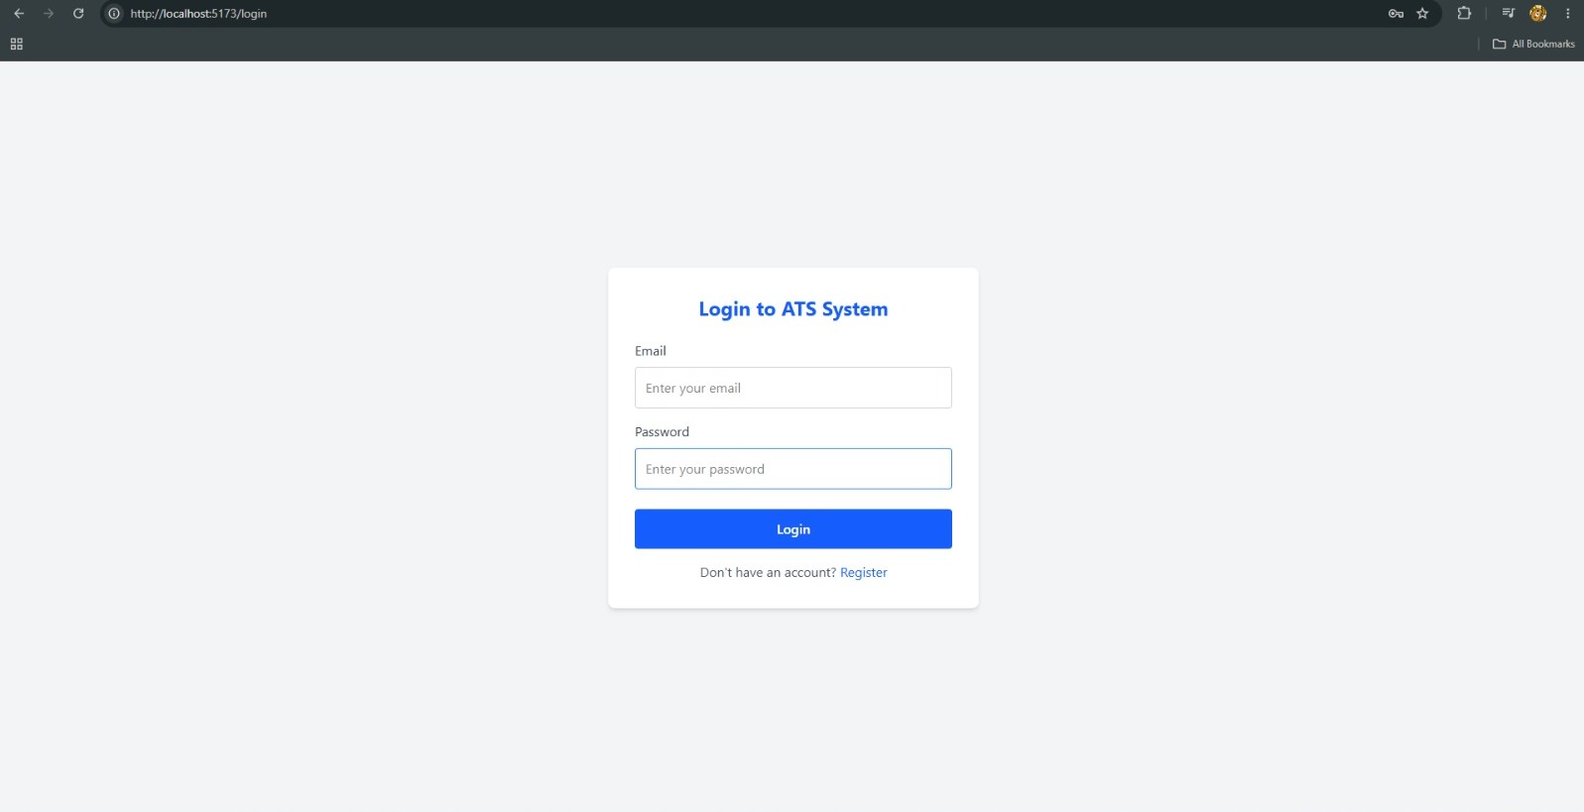

9.3 Registration Page
The Registration Page allows new users to create accounts within the system.
Features
- User Registration
- Recruiter Registration
- Data Validation
- Secure Password Storage
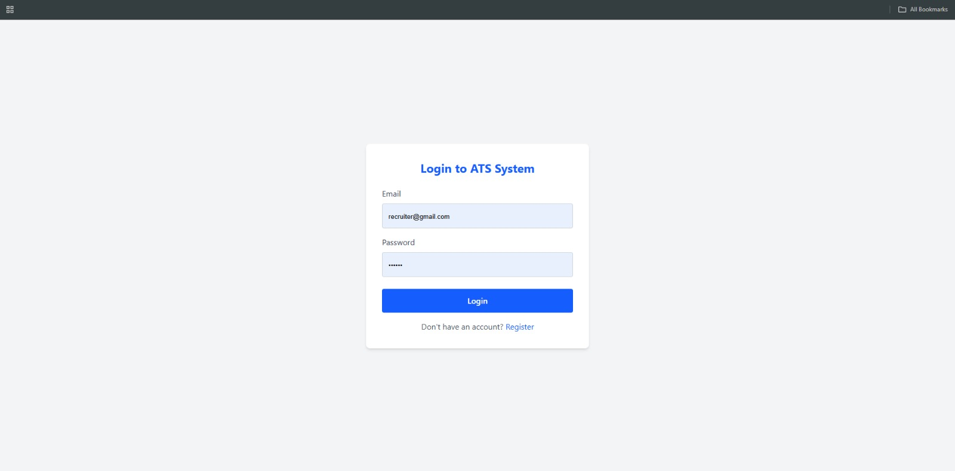
9.4 Candidate Dashboard
The Candidate Dashboard serves as the primary interface for job seekers.
Features
- Profile Management
- ATS Score Display
- Application Tracking
- Notifications
- Job Search Access
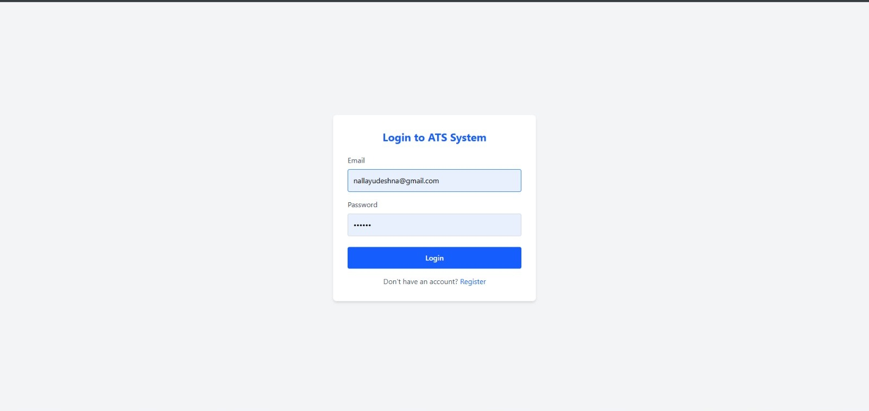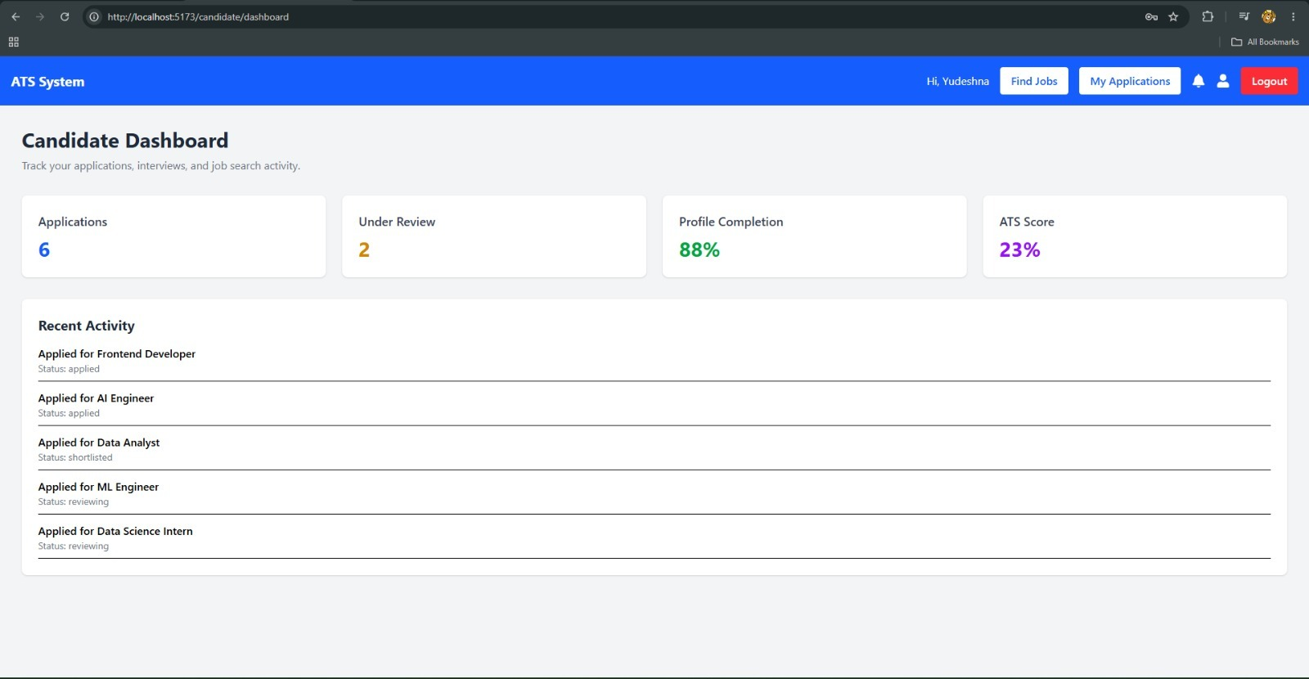
9.5 Recruiter Dashboard
The Recruiter Dashboard provides recruiters with recruitment management tools.
Features
- Job Management
- Applicant Review
- ATS Score Evaluation
- Recruitment Tracking
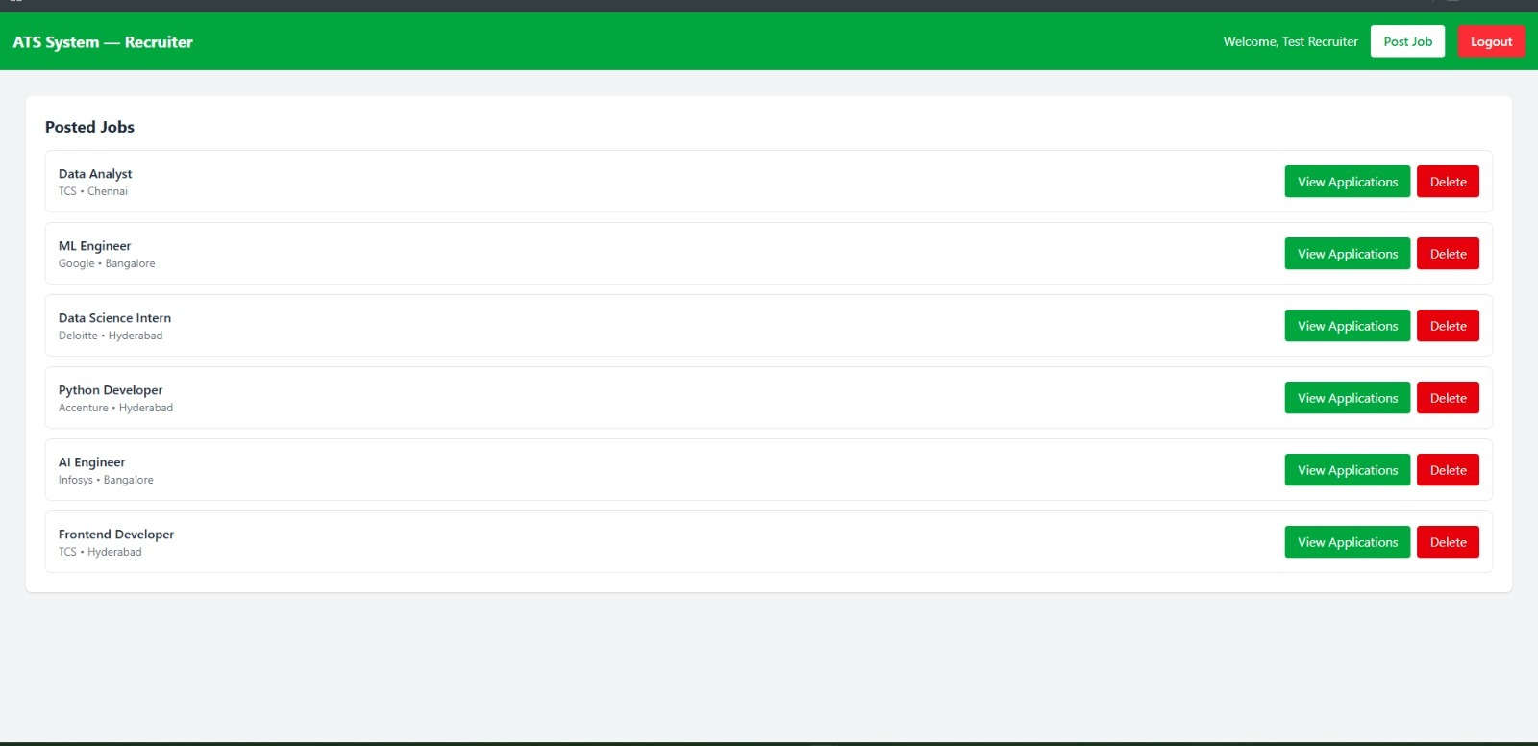
9.6 Job Search Page
The Job Search Page displays available job opportunities to candidates.
Features
- Browse Jobs
- View Job Details
- Apply for Jobs
- Skill-Based Search
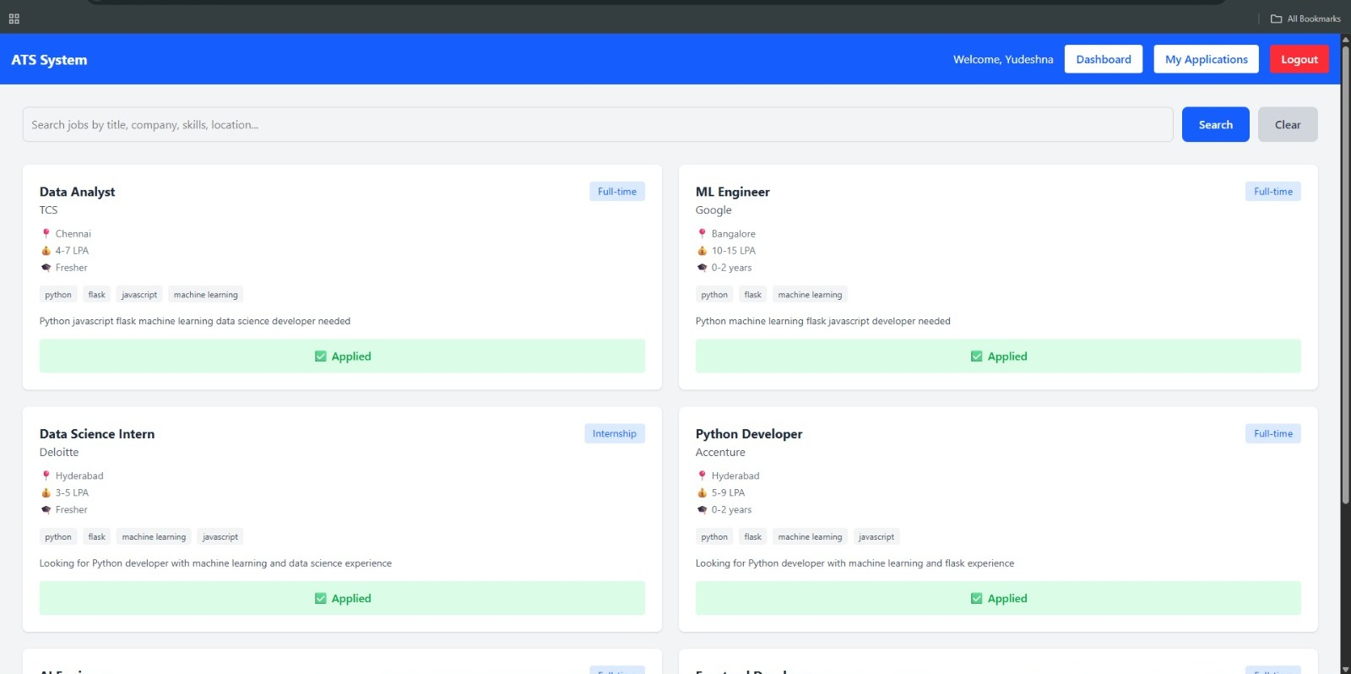

9.7 Application Tracking Page
This page enables candidates to monitor the progress of submitted applications.
Features
- Application History
- Status Tracking
- ATS Score Visibility
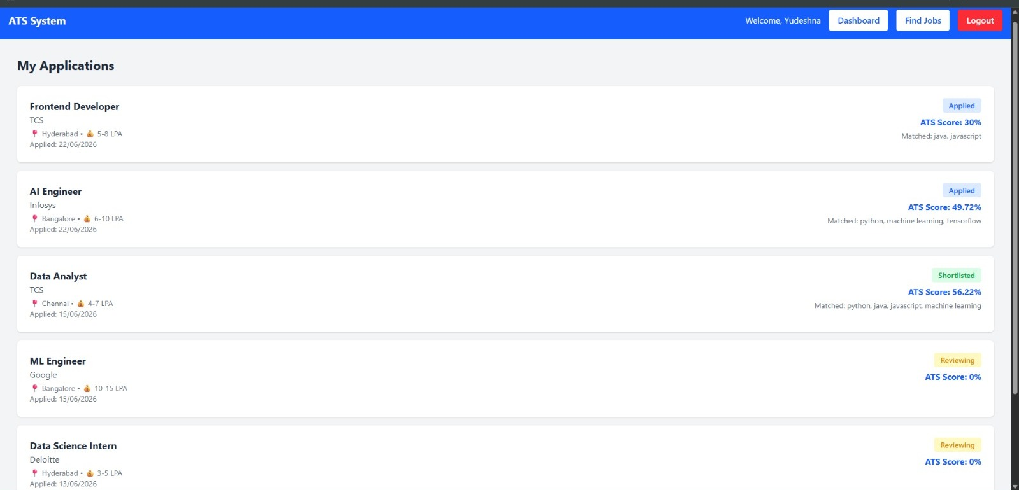
9.8 Candidate Profile Page
The Candidate Profile Page allows users to manage personal and professional information.
Features
- Profile Information
- Skills Management
- Education Details
- Resume Information
- 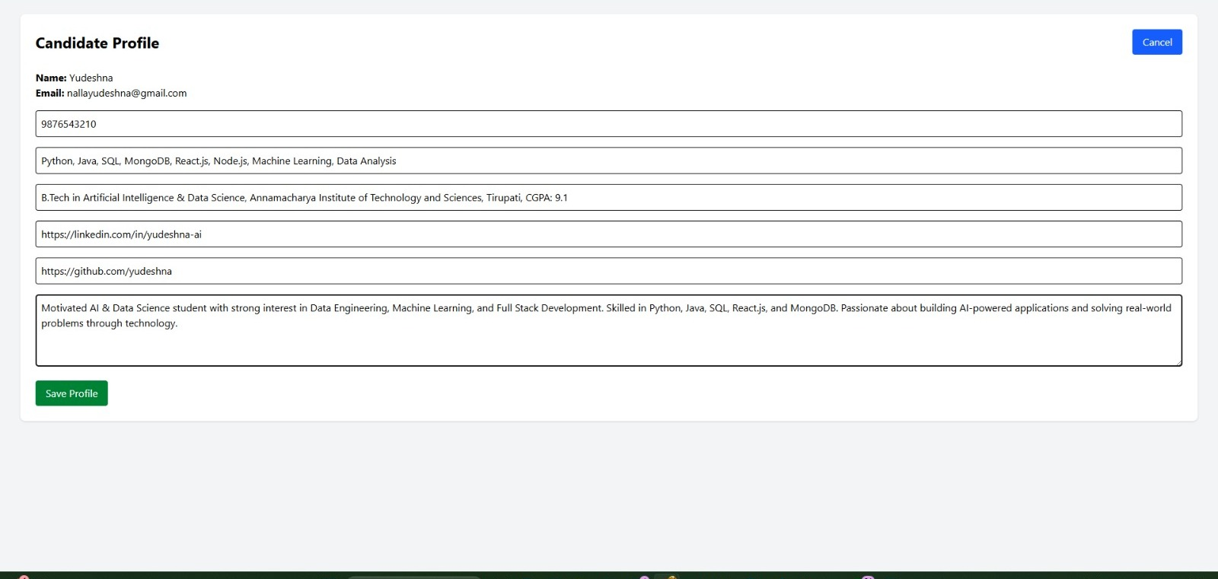
- 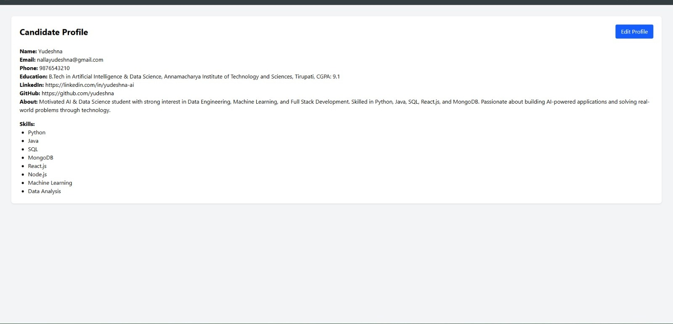

9.9 ATS Score Evaluation
The ATS Score Module evaluates uploaded resumes and generates scores to assist recruiters in candidate selection.
Features
- Resume Analysis
- Skill Matching
- ATS Score Generation
- Candidate Ranking
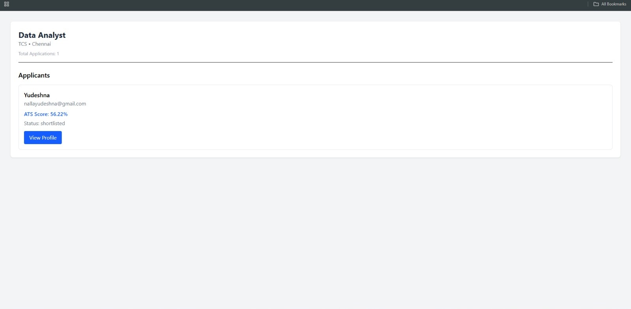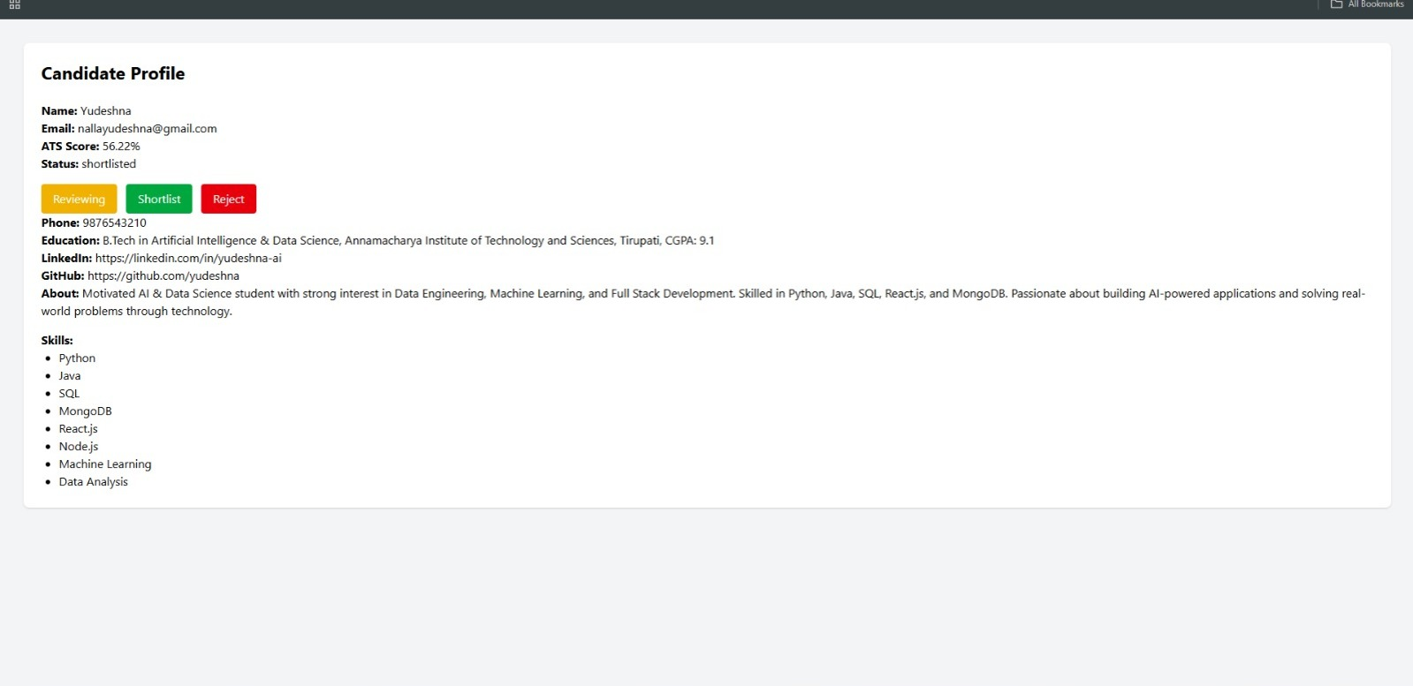
9.10 Test Results
The developed system was tested for different functionalities and produced successful results.
Test Case | Expected Result | Actual Result | Status
User Registration | User Created Successfully | Successful | Pass
User Login | Dashboard Access | Successful | Pass
Job Creation | Job Posted Successfully | Successful | Pass
Job Search | Available Jobs Displayed | Successful | Pass
Job Application | Application Submitted | Successful | Pass
Resume Upload | Resume Uploaded | Successful | Pass
ATS Score Generation | Score Generated | Successful | Pass
Application Tracking | Status Displayed | Successful | Pass
Notifications | Notifications Received | Successful | Pass

9.11 Outcome
The AI Job Application Tracking System successfully achieved its objectives by providing:
- Automated Recruitment Management
- Secure User Authentication
- Efficient Job Application Tracking
- Resume Upload and Management
- AI-Based ATS Score Generation
- Candidate Evaluation Support
The system demonstrated reliable performance and improved recruitment efficiency through automation and intelligent candidate assessment.

CHAPTER 10: FUTURE SCOPE AND CONCLUSION
10.1 Future Scope
The AI Job Application Tracking System has been designed as a scalable and extensible recruitment platform. Although the current system successfully automates job application tracking and ATS score generation, several enhancements can be incorporated in future versions to improve functionality and user experience.
1. Advanced Resume Parsing
Future versions can integrate Natural Language Processing (NLP) techniques to perform deeper resume analysis and extract information with greater accuracy.
2. AI-Based Candidate Ranking
Machine Learning algorithms can be incorporated to automatically rank candidates based on job requirements, skills, experience, and ATS scores.
3. Interview Scheduling System
An automated interview scheduling module can be added to simplify communication between recruiters and candidates.
4. Email and SMS Notifications
The system can be integrated with email and SMS services to provide real-time updates regarding application status and interview schedules.
5. Analytics Dashboard
Recruiters can be provided with visual analytics and reports related to job applications, candidate statistics, and hiring performance.
6. Cloud Deployment
The system can be deployed on cloud platforms such as AWS, Azure, or Google Cloud to improve scalability, reliability, and accessibility.
7. Video Interview Integration
Online interview functionality can be integrated directly into the platform, enabling seamless recruitment processes.
8. Mobile Application
A dedicated Android and iOS application can be developed to provide users with access to recruitment services from mobile devices.
9. Skill Recommendation System
AI can be used to recommend skills, certifications, and learning resources to candidates based on job market trends.
10. Multi-Language Support
Support for multiple languages can make the platform accessible to users from different regions and backgrounds.

CHAPTER 11: CONCLUSION
11.1 Conclusion
The AI Job Application Tracking System was successfully designed and developed to simplify and automate the recruitment process. The system provides a centralized platform for recruiters and candidates, enabling efficient job posting, application management, resume handling, and candidate evaluation.
The integration of Artificial Intelligence for ATS score generation enhances the recruitment process by assisting recruiters in identifying suitable candidates quickly and accurately. The system reduces manual effort, improves recruitment efficiency, and provides a better experience for both recruiters and job seekers.
The project successfully demonstrates the practical application of Full Stack Web Development, Database Management, REST API Development, Authentication and Authorization, and Artificial Intelligence techniques in solving real-world recruitment challenges.
The developed system achieved all the planned objectives and provides a strong foundation for future enhancements such as advanced AI capabilities, cloud deployment, interview scheduling, and intelligent candidate ranking.
Overall, the AI Job Application Tracking System serves as an effective solution for modern recruitment management and showcases the integration of web technologies with Artificial Intelligence to create a smart and efficient hiring platform.

REFERENCES
- React.js Official Documentation – https://react.dev
- Node.js Official Documentation – https://nodejs.org
- Express.js Official Documentation – https://expressjs.com
- MongoDB Official Documentation – https://www.mongodb.com/docs
- Mongoose Documentation – https://mongoosejs.com
- Python Official Documentation – https://docs.python.org
- Flask Documentation – https://flask.palletsprojects.com
- JSON Web Token (JWT) Documentation – https://jwt.io
- Tailwind CSS Documentation – https://tailwindcss.com
- Postman Documentation – https://learning.postman.com

APPENDIX
Project Team
- N. Yudeshna
- G. Sravanth
- K. Harish
Project Title
AI Job Application Tracking System
Technologies Used
- React.js
- Tailwind CSS
- Node.js
- Express.js
- MongoDB
- Mongoose
- Python
- Flask
- JWT Authentication
- Multer
- Postman
Project Repository
GitHub Repository:
https://github.com/yudeshna/Mini-project

